CRYPTOGRAPHY LAB – 3
Aishwarya V 23BRS1049

Aim
To implement Chinese Remainder Theorem (CRT), Miller–Rabin Primality Test, and Trial Division Algorithm.
Theory

Chinese Remainder Theorem (CRT)
The Chinese Remainder Theorem is a mathematical technique used to solve a system of simultaneous congruences. If a number satisfies:

where the moduli are pairwise coprime, then there exists a unique solution modulo:

CRT allows a large modular computation to be broken into smaller independent computations, making it extremely efficient.

Applications in Cryptography
CRT is used in:
· RSA decryption optimization
· Digital signatures
· Secure authentication systems
· Secret sharing schemes
By splitting large modulus computations into smaller ones, CRT significantly improves speed.

Miller–Rabin Primality Test
The Miller–Rabin algorithm is a probabilistic primality test used to determine whether a given number is prime.
Every odd number can be written as:

where d is odd.
The algorithm selects a random number (called a witness) and checks whether it satisfies certain modular exponentiation properties. If these conditions fail, is definitely composite. If they pass, is probably prime.
Repeating the test multiple times reduces the probability of error exponentially.

Applications in Cryptography
Miller–Rabin is used in:
· RSA key generation
· Prime validation for encryption
· Blockchain and digital security systems
It is preferred because it is extremely fast even for very large numbers.

Trial Division Algorithm
Trial Division is the simplest method to test if a number is prime. It checks whether the number is divisible by any integer from 2 up to:

If any divisor is found, the number is composite. Otherwise, it is prime.

Applications
· Small number primality checking
· Educational and verification purposes
· Debugging and correctness testing
It is slow for large numbers and therefore not used in real cryptographic systems.
Working and Explanation
- Working of Chinese Remainder Theorem The algorithm works as follows:
  - Compute the product of all moduli:

  - For each congruence, compute:
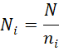

  - Find the modular inverse of modulo using the Extended Euclidean Algorithm:
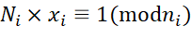
  - Multiply:
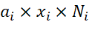

  - Sum all results and take modulo :
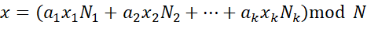
This gives the unique solution.
CRT is used in RSA to split a large decryption into two smaller ones, making it up to 4× faster.

- Working of Miller–Rabin Algorithm 1. Write:
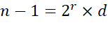
  - Pick a random integer such that:
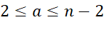
  - Compute:
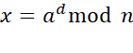
  - If:
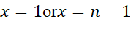
then the test passes for this iteration.
  - Otherwise, square repeatedly:
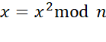
If ever becomes , the number passes this iteration.
If it becomes 1 without becoming , the number is composite.
  - Repeat this process times.
More iterations mean higher confidence that the number is prime.

- Working of Trial Division
  - If the number is less than or equal to 1, it is not prime.
  - Start from 2 and check divisibility:
n%i=0 3. Continue until:
i<root(n)
- If any divisor is found, the number is composite.
- Otherwise, it is prime.
This works because any composite number must have at least one factor less than or equal to its square root.

Code – Chinese Remainder Theorem
#include <stdio.h>
int extendedGCD(int a, int b, int *x, int *y) {
if (b == 0) {
*x = 1;
*y = 0;
return a;
}
int x1, y1;
int gcd = extendedGCD(b, a % b, &x1, &y1);
*x = y1;
*y = x1 - (a / b) * y1;
return gcd;
}
int chineseRemainder(int a[], int n[], int size) {
int N = 1;
for (int i = 0; i < size; i++)
N *= n[i];

int result = 0;

for (int i = 0; i < size; i++) {
int Ni = N / n[i];
int x, y;
extendedGCD(Ni, n[i], &x, &y);
x = (x % n[i] + n[i]) % n[i];
result += a[i] * x * Ni;
}
return result % N;
}

int main() {
int a[] = {2, 3, 1};
int n[] = {3, 4, 5}; // m
int size = 3;

int x = chineseRemainder(a, n, size);
printf("Solution x = %d\n", x);
return 0;
}
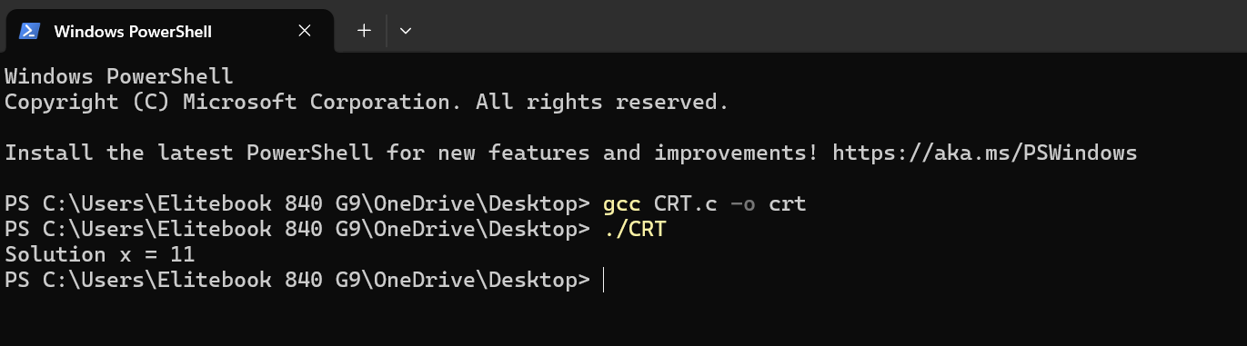

Code – Miller Rabin
#include <stdio.h>
#include <stdlib.h>
#include <time.h>

// Modular exponentiation
long long power(long long a, long long d, long long n) {
long long result = 1;
a = a % n;
while (d > 0) {
if (d % 2 == 1)
result = (result * a) % n;
d = d / 2;
a = (a * a) % n;
}
return result;
}

int millerRabin(long long n, int k) {
if (n <= 1 || n == 4) return 0;
if (n <= 3) return 1;

long long d = n - 1;
while (d % 2 == 0)
d /= 2;

for (int i = 0; i < k; i++) {
long long a = 2 + rand() % (n - 4);
long long x = power(a, d, n);

if (x == 1 || x == n - 1)
continue;

int composite = 1;
while (d != n - 1) {
x = (x * x) % n;
d *= 2;

if (x == n - 1) {
composite = 0;
break;
}
}
if (composite)
return 0;
}
return 1;
}

int main() {
long long n = 7919;
int k = 5;

srand(time(NULL));

if (millerRabin(n, k))
printf("%lld is probably prime\n", n);
else
printf("%lld is composite\n", n);

return 0;
}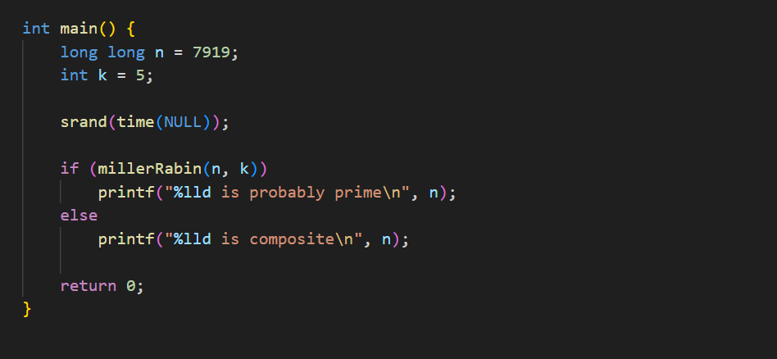
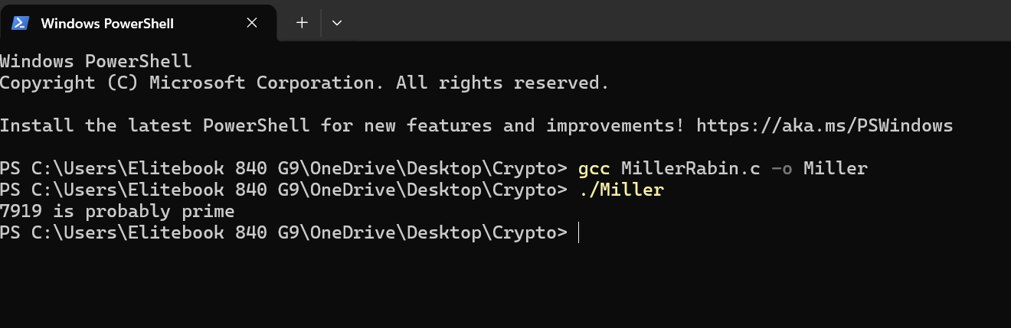

Code – Trial Division
#include <stdio.h>
#include <math.h>

int isPrimeTrial(int n) {
if (n <= 1)
return 0;

for (int i = 2; i <= sqrt(n); i++) {
if (n % i == 0)
return 0;
}
return 1;
}

int main() {
int n = 29;

if (isPrimeTrial(n))
printf("%d is prime\n", n);
else
printf("%d is not prime\n", n);

return 0;
}
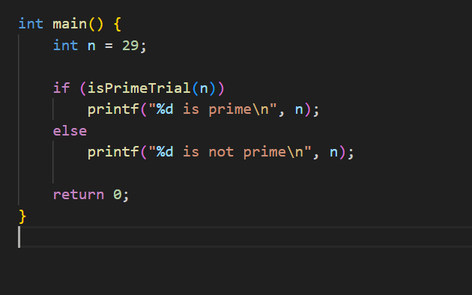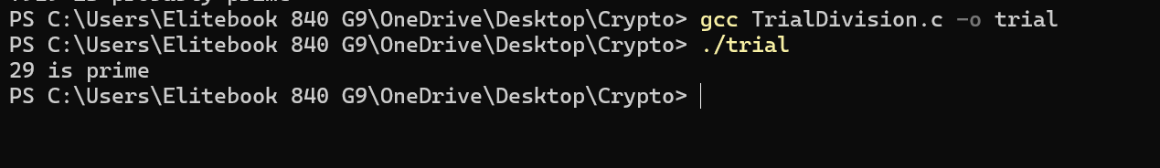

Graphs
- Time Complexity vs Input Size
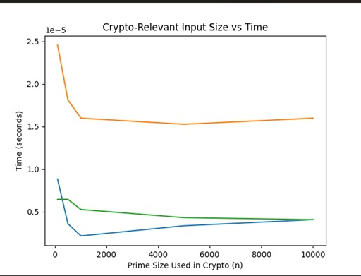

- Probability of Error vs Iterations (Miller Rabin)
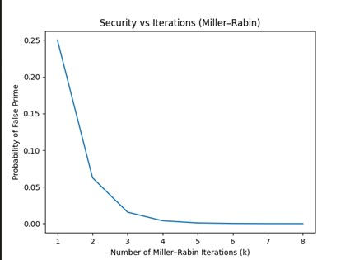

- RSA Speedup using CRT
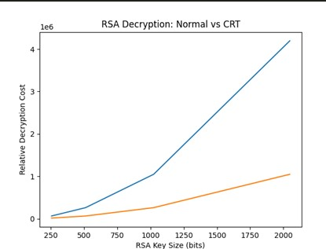

Conclusion
The experiment demonstrated how CRT, Miller–Rabin, and Trial Division form the backbone of cryptographic systems. CRT improves performance in modular arithmetic, Miller–Rabin enables fast prime checking for large numbers, and Trial Division is useful for small inputs and verification.

